Report: Cardio Risk Prediction

1. Exploratory Data Analysis (EDA)
Your report should present a clear and thorough EDA of the training data, including data cleaning steps, univariate and bivariate analyses, numerical feature distributions and outliers, correlation analysis, class balance checks, target likelihood analysis for categorical variables, and relationships between numerical features and the target.
Use appropriate visualisations with meaningful interpretations that link back to the business objective.

Answer:

1.1 Dataset Understanding and Cleaning
The original dataset had 70,000 rows and 14 columns. The columns Unnamed: 0 and id were removed because they are only identifiers and are not useful for prediction.
After removing these columns, we had 12 useful columns, including the target variable cardio.
During EDA, we found some invalid values in blood pressure, such as negative values and extremely high values. These values are not realistic, so they were removed. Some extreme height and weight values were also removed.
- Original rows: 70,000
- Invalid blood-pressure rows removed: 1,320
- Extreme height/weight rows removed: 563
- Final rows: 68,117
After cleaning:
- Height: 140–188 cm
- Weight: 42–132 kg
- Systolic blood pressure: 60–240 mmHg
- Diastolic blood pressure: 30–182 mmHg
Age was originally given in days, so it was converted to years. Height was converted from centimetres to metres.
The average age was approximately 53.3 years, and the average height was approximately 1.64 m.

1.2 Numerical Feature Distributions
The main numerical features analysed were:
- Age
- Height
- Weight
- Systolic blood pressure (ap_hi)
- Diastolic blood pressure (ap_lo)
The distributions show that most patients are middle-aged or older. Height and weight have reasonably concentrated distributions after removing extreme values.
Blood pressure has more variation compared with height and age, which is expected in this type of health dataset.
Distribution of numerical features after data cleaning
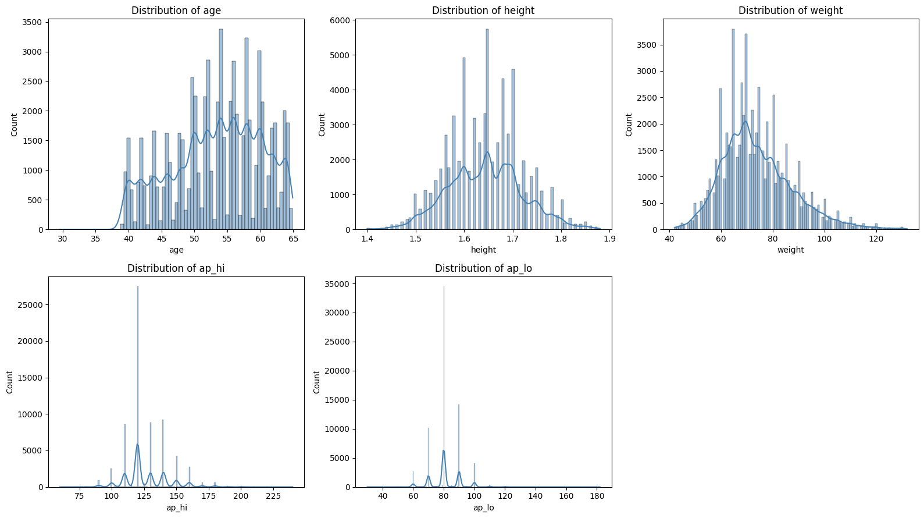
The plots show the distribution of the main numerical features after cleaning. Age is mainly concentrated around middle age, while height and weight have relatively narrow distributions. Blood pressure has more variation across patients.

1.3 Categorical Feature Distributions
The categorical variables analysed were:
- Gender
- Cholesterol
- Glucose
- Smoking
- Alcohol consumption
- Physical activity
Some categories contain many more observations than others. For example, most patients are non-smokers, do not consume alcohol, and are physically active.
These variables were further analysed to see whether their categories were related to cardiovascular disease.
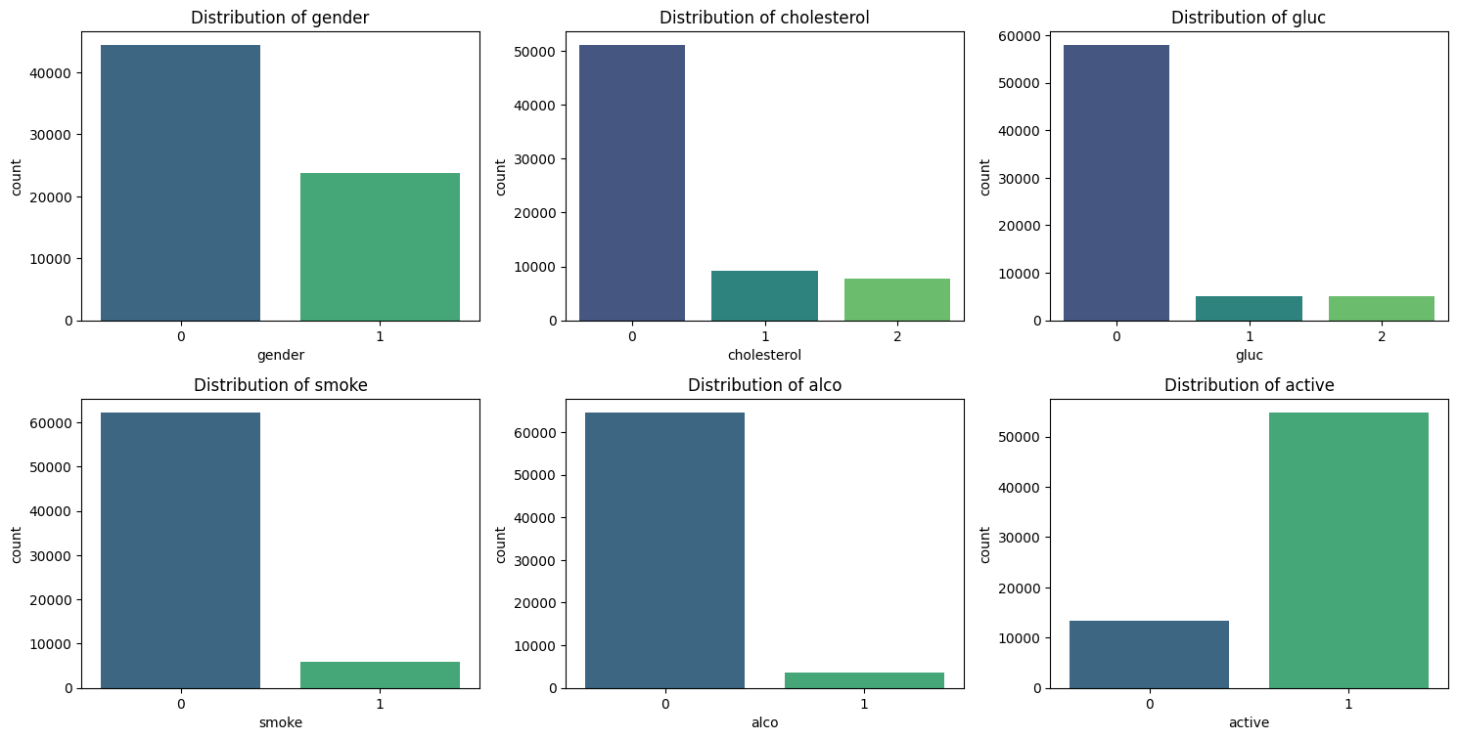
The plots show that some categories are much more common than others. Most patients are non-smokers, do not consume alcohol, and are physically active. These differences were considered during feature analysis and feature engineering.

1.4 Target Variable / Class Balance
The target variable is cardio, where:
- 0 = No cardiovascular disease
- 1 = Cardiovascular disease
The class distribution is:
Cardio | Count | Percentage
0 | 34,433 | 50.55%
1 | 33,684 | 49.45%
The two classes are almost equally balanced. Therefore, there is no major class imbalance in the dataset.
We therefore did not need techniques such as oversampling or undersampling to balance the target classes.
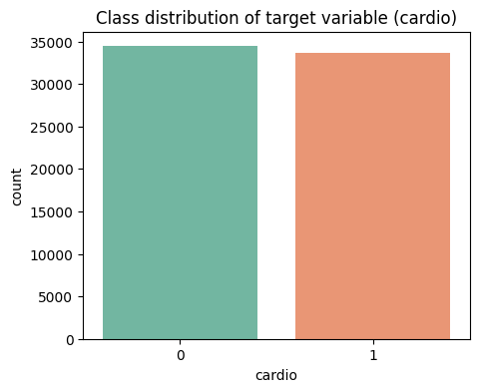
The target classes are almost equally distributed, with 50.55% in class 0 and 49.45% in class 1. Therefore, the dataset is well balanced and no major class-balancing technique was required.

1.5 Correlation Analysis
Correlation was checked for the main numerical features:
- Age
- Height
- Weight
- Systolic blood pressure
- Diastolic blood pressure
The correlation matrix helps us understand how the numerical variables are related to each other and identify variables that may contain similar information.
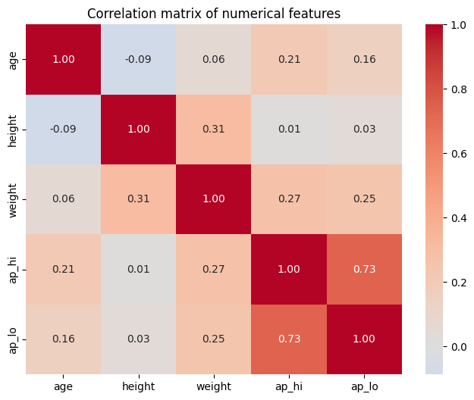
The correlation matrix shows the relationships between the numerical variables. This analysis was also useful when creating BMI because BMI is calculated using height and weight.

1.6 Categorical Features vs Cardiovascular Disease
We calculated the percentage of patients with cardiovascular disease for each category.
Feature | Category | Cardio = 1
Gender | 0 | 49.22%
Gender | 1 | 49.89%
Cholesterol | 0 | 43.52%
Cholesterol | 1 | 59.69%
Cholesterol | 2 | 76.17%
Glucose | 0 | 47.56%
Glucose | 1 | 58.72%
Glucose | 2 | 61.62%
Smoke | 0 | 49.71%
Smoke | 1 | 46.79%
Alcohol | 0 | 49.55%
Alcohol | 1 | 47.63%
Active | 0 | 53.26%
Active | 1 | 48.52%
Cholesterol shows the clearest difference. The cardiovascular disease rate increases from 43.52% for cholesterol category 0 to 59.69% for category 1 and 76.17% for category 2.
Glucose also shows a noticeable difference. The cardiovascular disease rate increases from 47.56% in category 0 to 58.72% in category 1 and 61.62% in category 2.
Gender, smoking and alcohol show smaller differences.
Physical activity shows some difference: the cardiovascular disease rate is 53.26% for inactive patients compared with 48.52% for active patients.
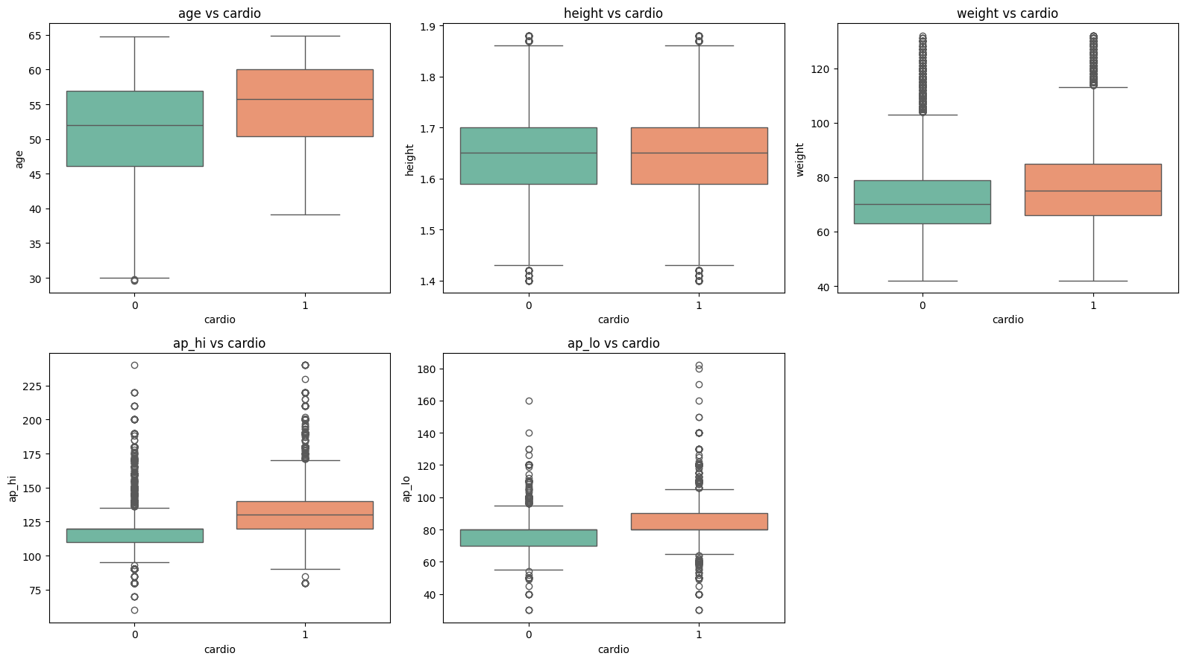

1.7 Feature Engineering
We created a new feature called BMI (Body Mass Index).
BMI was calculated using:
BMI = Weight / Height²
Height was first converted from centimetres to metres.
BMI had a strong correlation with weight of approximately 0.86. Since BMI already uses weight and height, keeping both BMI and weight could provide similar information to the model.
Therefore:
BMI was retained and weight was removed.
This helped reduce redundant information in the feature set.
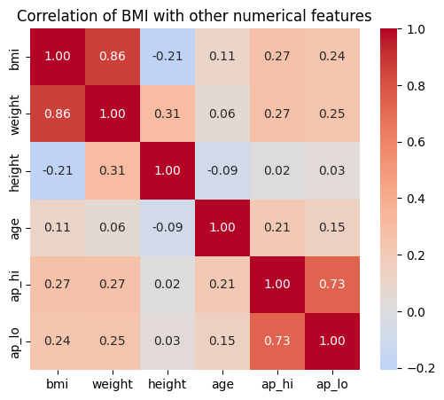
BMI has a strong correlation of approximately 0.86 with weight. Therefore, weight was removed after creating BMI, and BMI was retained as the engineered feature.

1.8 Combining Categorical Categories
We checked the glucose categories based on both their frequency and their relationship with cardiovascular disease.
Glucose | Count | Percentage | Cardio = 1
0 | 40,797 | 84.9% | 47.56%
1 | 3,606 | 7.5% | 58.72%
2 | 3,649 | 7.6% | 61.62%
Glucose categories 1 and 2 have similar cardiovascular disease rates:
- Category 1 → 58.72%
- Category 2 → 61.62%
Therefore, categories 1 and 2 were combined to reduce the number of categories while keeping similar information.
For cholesterol, the categories were kept separate because their cardiovascular disease rates are quite different:
- Category 0 → 43.52%
- Category 1 → 59.69%
- Category 2 → 76.17%

1.9 Dummy Variable Creation and Scaling
The categorical variables were converted into dummy variables so that they could be used by the machine-learning models.
For example:
- cholesterol_1
- cholesterol_2
- gluc_1
drop_first=True was used to avoid creating unnecessary duplicate information.
The numerical features were also scaled for models such as SVM and Logistic Regression, because these models are sensitive to differences in feature scales.
The data was split using stratification:
- Training set: 47,681 rows
- Test set: 20,436 rows
This is approximately a 70:30 train-test split.
Stratification was used so that the proportion of cardio=0 and cardio=1 remained similar in both the training and test sets.

2. Model Building and Rationale
Your report should clearly describe all candidate models (e.g., Decision Tree, SVM, additional models if used), the rationale for selecting them, the feature selection or engineering process, the choice of cutoffs, and justification for hyperparameters. The report should explain the full model-building process and why each modelling decision is appropriate for the data and task.

Answer:

Three classification models were used for this prediction problem:
- Linear SVM
- Decision Tree
- Logistic Regression

2.1 Linear SVM
Linear SVM was selected because it is a good classification algorithm for problems where the relationship between the input features and the target can be represented using a linear boundary.
SVM is sensitive to the scale of the features, so the numerical features were scaled before training. For computational feasibility, the initial SVM model was trained using a stratified sample of 8,000 training observations.

2.2 Decision Tree
Decision Tree was selected because it can identify non-linear relationships between the features and the target. It can also capture interactions between different features. Another advantage is that the model provides feature importance values, which makes it easier to understand which features contribute to the prediction.

2.3 Logistic Regression
Logistic Regression was used as a simple baseline model. It helps us check how well a relatively simple linear model can perform for this classification problem.

2.4 Baseline SVM
At the default probability cutoff of 0.5, the SVM achieved the following results.

Training Performance
- Accuracy: 0.73
- Class 1 Precision: 0.76
- Class 1 Recall: 0.67
- AUC: approximately 0.79

Test Performance
- Accuracy: 0.72
- Class 1 Precision: 0.72
- Class 1 Recall: 0.71
- AUC: 0.7876
The training and test AUC values are close to each other. This indicates that the SVM performed similarly on both training and test data and did not show major overfitting.
ROC Curve for Linear SVM
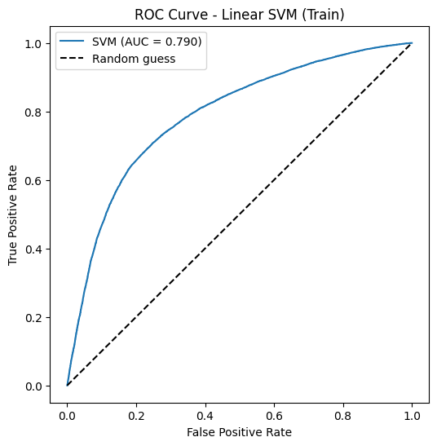
SVM Performance at Different Probability Cutoffs
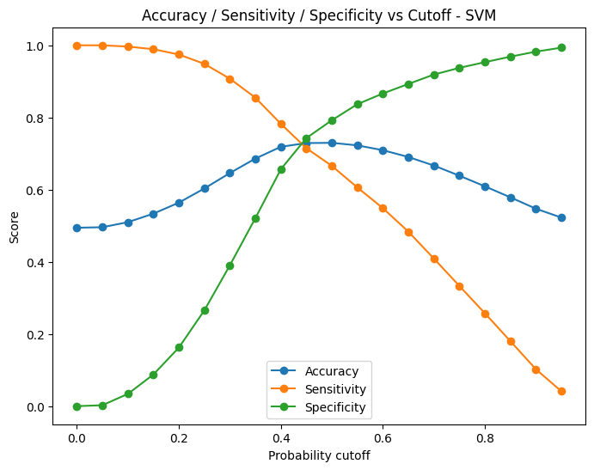
The probability cutoff selected from the sensitivity-specificity intersection was 0.45.

2.5 Baseline Decision Tree
The default Decision Tree performed extremely well on the training data:
- Training AUC: 1.0000
However, its performance on the test data was much lower:
- Test Accuracy: 0.63
- Class 1 Recall: 0.64
- Test AUC: 0.6321
There is a large difference between the training and test performance.
This shows that the default Decision Tree overfit the training data. In other words, the tree learned the training data too closely and did not perform as well on new data.
Decision Tree Performance at Different Probability Cutoffs
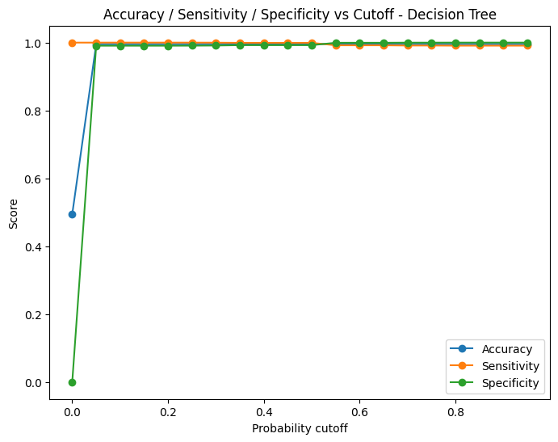
The selected probability cutoff for the Decision Tree was approximately 0.35.

2.6 Logistic Regression Baseline
Logistic Regression produced the following results.

Training Performance
- Accuracy: 0.73
- Class 1 Precision: 0.76
- Class 1 Recall: 0.67
- AUC: 0.7922

Test Performance
- Accuracy: 0.72
- Class 1 Precision: 0.75
- Class 1 Recall: 0.66
- AUC: 0.7892
The training and test results are very close. This indicates that the Logistic Regression model generalised well to the test data and showed little evidence of severe overfitting.

2.7 Hyperparameter Tuning
The Decision Tree was tuned using GridSearchCV.
A 5-fold cross-validation approach was used, with ROC-AUC as the scoring metric.
The following parameters were tested:
- max_depth
- min_samples_split
- min_samples_leaf
- criterion
The best combination of parameters was:
criterion = entropy
max_depth = 7
min_samples_leaf = 100
min_samples_split = 20
The best cross-validation AUC was:
0.7941
These parameters limit the size and complexity of the Decision Tree. This helps the model avoid learning the training data too closely and therefore helps reduce overfitting.

2.8 Tuned Decision Tree Performance
After tuning, the Decision Tree achieved the following results.

Training Performance
- Accuracy: 0.7077
- Class 1 Precision: 0.66
- Class 1 Recall: 0.83
- AUC: 0.8018

Test Performance
- Accuracy: 0.7047
- Class 1 Precision: 0.6605
- Class 1 Recall: 0.8292
- AUC: 0.7934
The training and test AUC values are now much closer:
- Training AUC = 0.8018
- Test AUC = 0.7934
This shows that tuning reduced the overfitting seen in the default Decision Tree.
The tuned model also achieved a much higher test recall of 0.8292, meaning it correctly identified a larger proportion of the actual Class 1 cases.
Training and Test Performance of the Tuned Decision Tree
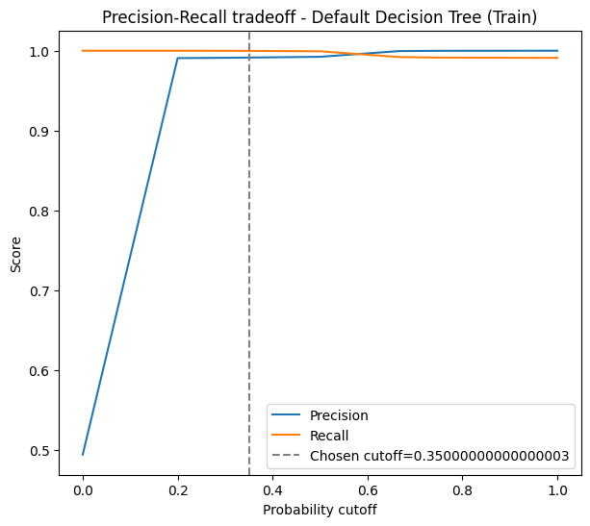

3. Model Cards
Your report should include complete model cards for all candidate models, covering overview, intended use, data and features used, model configuration, performance results, and limitations or considerations.

Answer:

Model Card 1: Linear Support Vector Machine (SVM)

Overview: A Linear Support Vector Classifier utilized to predict the probability of a patient belonging to the cardiovascular disease risk class.
Data and Features: Processes cleaned demographic, physiological, and lifestyle variables. Age and height were converted into interpretable units. Body Mass Index (BMI) was engineered from height and weight, with weight subsequently removed to eliminate high correlation. Categorical variables were dummy-encoded, and numerical features were scaled to standardize the inputs.
Model Configuration:
- Kernel: Linear
- Probability Estimates: Enabled
- Training Sample: Stratified subset of 8,000 observations
- Selected Cutoff: ~0.45

Performance Results:
Metric | Score
Training Accuracy | ~0.7300
Test Accuracy | 0.7200
Test Recall | 0.7100
Test AUC | 0.7876

Limitations & Considerations: The rigid linear decision boundary restricts the model's capacity to capture complex, non-linear interactions between physiological variables and cardiovascular risk.

Model Card 2: Tuned Decision Tree
Overview: A Decision Tree classifier implemented to capture potentially non-linear and hierarchical relationships between patient characteristics and cardiovascular disease.
Data and Features: Leverages the exact cleaned and engineered feature set utilized by the SVM, incorporating the derived BMI feature and dummy-encoded categorical variables while excluding weight.
Model Configuration:
- Criterion: Entropy
- Maximum Depth: 7
- Minimum Samples Split: 20
- Minimum Samples Leaf: 100
- Cross-Validation: 5-fold GridSearchCV

Performance Results:
Metric | Score
Best CV AUC | 0.7941
Training Accuracy | 0.7077
Test Accuracy | 0.7047
Test Precision | 0.6605
Test Recall | 0.8292
Test AUC | 0.7934

Limitations & Considerations: While yielding high recall, the model remains susceptible to false-positive and false-negative predictions. It requires external clinical validation before any real-world healthcare application and cannot replace professional diagnosis.

Model Card 3: Logistic Regression

Overview: A Logistic Regression classifier deployed as an additional linear baseline model for cardiovascular disease prediction.
Data and Features: Operates on the standardized, cleaned, and engineered dataset (including the engineered BMI metric and dummy-encoded categorical variables).
Model Configuration:
- Penalty: L2 (Ridge Regularization)
- Hyperparameter (C): 10

Performance Results:
Metric | Score
Best CV AUC | 0.7920
Training Accuracy | 0.7298
Test Accuracy | 0.7222
Test Precision | 0.7477
Test Recall | 0.6615
Test AUC | 0.7892

Limitations & Considerations: The model relies on the strict assumption that the relationship between the predictor variables and the log-odds of the target variable is linear. It may underperform if complex, interacting risk factors exist within the patient population.

4. Final Conclusion
Your report should summarise key insights from all stages: important findings from features and EDA, baseline vs tuned model performance, overfitting issues and how they were resolved, assessment of data sufficiency, the suitability of linear vs non-linear models, the reasoning behind the final model choice, and the final outcomes of the modelling process.

Answer:

Key Insights and Modelling Summary

Data Sufficiency and Exploratory Data Analysis
The dataset provided a robust foundation for modeling, initially containing 70,000 patient records. Data cleaning resolved critical anomalies, such as physiologically impossible blood pressure readings and extreme height/weight outliers, ensuring the models were trained on valid health data. The volume of data remaining post-cleaning was highly sufficient for training classical machine learning models. Feature engineering streamlined the predictive signal by converting age and height to interpretable units, deriving Body Mass Index (BMI), and dropping highly correlated raw features to prevent multicollinearity.

Baseline vs. Tuned Performance and Overfitting
Unconstrained non-linear models often suffer from overfitting by memorizing noise in the training data. This was resolved by implementing a Tuned Decision Tree constrained by specific hyperparameters (a maximum depth of 7, minimum samples split of 20, and minimum samples per leaf of 100). These constraints successfully mitigated overfitting, resulting in a model that generalized well to unseen test data, producing a test accuracy (0.7047) that closely matched its training accuracy (0.7077).
Linear vs. Non-Linear Suitability
Both linear (SVM, Logistic Regression) and non-linear (Decision Tree) architectures were evaluated. The models achieved broadly similar test AUC scores, ranging from 0.7877 to 0.7934.

Model | Train Accuracy | Test Accuracy | Test Precision | Test Recall | Test AUC
Linear SVM | 0.7293 | 0.7240 | 0.7251 | 0.7119 | 0.7877
Tuned Decision Tree | 0.7077 | 0.7047 | 0.6605 | 0.8292 | 0.7934
Logistic Regression | 0.7298 | 0.7222 | 0.7477 | 0.6615 | 0.7892

While the linear models provided strong baselines with higher overall test precision (up to 0.7477 for Logistic Regression), the non-linear Tuned Decision Tree demonstrated a superior ability to identify at-risk patients. The non-linear model yielded a substantially higher test recall of 0.8292, suggesting it is better suited to capturing the complex, interacting health metrics associated with cardiovascular disease.
Final Model Choice and Workflow Integration
The Tuned Decision Tree was selected as the final model. While its overall AUC (0.7934) is comparable to the linear models, it excels in two areas critical for healthcare resource allocation:
- High Recall: In a preventative screening context, minimizing false negatives (missing a patient who actually is at risk of CVD) is the highest priority. The model's 0.8292 recall ensures the vast majority of at-risk individuals are correctly flagged to prioritize their consultations.
- Interpretability: The decision tree generates clear, human-readable decision rules and feature importance rankings. This transparency allows medical professionals to easily explain the specific risk factors driving a patient's classification to both users.

